Joint Learning Disability Commissioning Strategy (Big Plan)
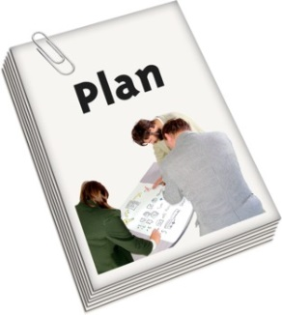
Easy read Consultation questions

The Big Plan (The big ideas for Learning Disabilities)

Question 1: Please use the box below to tell us what you think about the Big Plan.

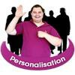
Personalisation (Having more control over the support you get)
Question 1: Do you agree with what we have said about Personalisation?
Yes No

Question 2: Is there anything else you would like to say about Personalisation?

Accommodation (where you live)
Question 1: Do you agree with what we have said about Accommodation?
Yes No

Question 2: Is there anything else you would like to say about Accommodation?

Healthcare
Question 1: Do you agree with what we have said about Healthcare?
Yes No

Question 2: Is there anything else you would like to say about Healthcare?

Employment, Education and Daytime Activities
Question 1: Do you agree with what we have said about Employment, Education and Daytime Activities?
Yes No

Question 2: Is there anything else you would like to say about Employment, Education and Daytime Activities?

Preparing for Adulthood (Moving from children’s to adult’s services)
Question 1: Do you agree with what we have said about Preparing for Adulthood?
Yes No

Question 2: Is there anything else you would like to say about Preparing for Adulthood

Support for Carers
Question 1: Do you agree with what we have said about Support for Carers?
Yes No

Question 2: Is there anything else you would like to say about Support for Carers?

Making it Happen
Question 1: Do you agree with what we have said about Making it Happen?
Yes No

Question 2: Is there anything else you would like to say about Making it Happen?

About you

Question 1: Who is filling in this questionnaire?

Service user Carer Professional Other

Question 2: Do you live in Leicester City?

Yes No

Question 3: Your age

Your date of birth - …………………………………………………

How old are you? - …………………………………………………

I don’t want to say

Question 4: Gender

Female Male Trans woman

Trans man Other ……………. …… Prefer not to say

Question 5: Disability

Do you consider yourself to be a disabled person?

Yes No Prefer not to say

Question 6: Sexual Orientation how would you describe yourself?

Bisexual Gay/Lesbian Heterosexual/ or straight

Prefer not to say other (please write in) …………………………………

Question 7: Ethnicity (your family background)

a) Asian or Asian British
Bangladeshi Indian Pakistani
Any other Asian background (please write in) ……………………………….

b) Black or Black British
African Caribbean Somali
Any other Black background (please write in) ………………………………..

c) Chinese
Any other Chinese background (please write in) ……………………………

d) Dual / Multiple Heritage
Asian & White Black African & White Black Caribbean & White
Any other Heritage background (please write in) ……………………………

e) White
British European Irish
Any other White background (please write in) ……………………………….

f) Other ethnic group
Gypsy/Romany/Irish traveller
Any other ethnic group (please write in) ………………………………………

g) Prefer not to say

