Leicester Local Plan
Issues and Options
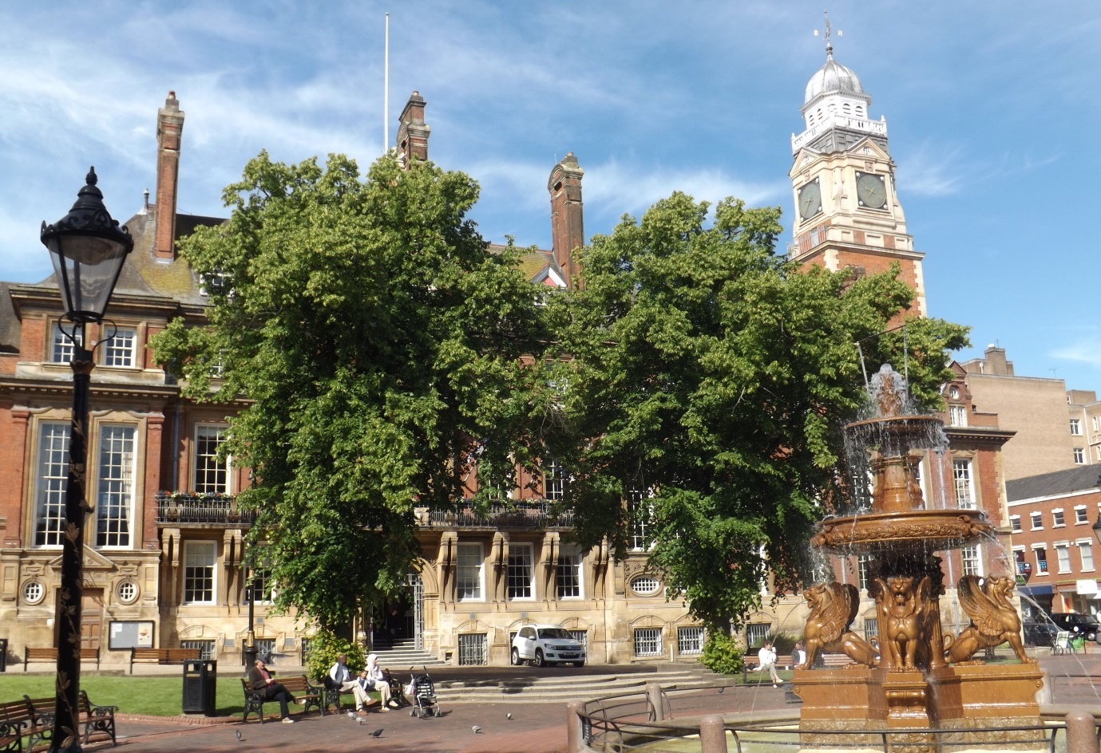

Findings of the public consultation
03/07/2015

Prepared by:
Planning, Transportation and Economic Development

This report provides a summary of the findings of the public consultation.
It includes information about:
- The Issues and Options under consideration;
- The consultation methods;
- The public response and views expressed;
- The decisions taken in light of what was learnt.

Background

Leicester Local Plan: Issues and Options Document
Leicester City Council has begun preparation of a new Local Plan which will set out a vision and objectives for the growth of the city over the next 15 years. It will outline how the council intends to respond to local priorities and how it will meet the social, economic and environmental challenges and opportunities that face the city. It will also identify broad locations, the scale and type of development and supporting infrastructure that will be required in the city.

The Issues and Options consultation stage marked the start of the Local Plan process. It provided the community of Leicester and other stakeholders with the opportunity to suggest any issues they feel should be addressed. They were able to comment on which of the options they thought were most appropriate, and told us about any other options that they may have had. Some of the big questions we asked in the consultation document included;

• Where should new development such as housing and employment be located?
• How and where should new jobs be created?
• How can we protect our natural and historic environment?
• How can we promote good design in buildings and spaces?
• How can we create a more healthy and active city?
• How can we encourage development which is more environmentally friendly and energy efficient?
• How do we encourage more people to travel by cycle, bus and walk whilst recognising travel by car is essential for some individuals and city businesses?

The council was also seeking suggestions of sites or groups of sites where there might be the opportunity for redevelopment or a change of use. Suitable sites will be allocated within the new Local Plan to provide for future needs including new places for people to live, office and industrial space, green space and essential services such as educational and community facilities.

It is your city and we want you to help us shape future development to further improve the quality of life and make the most of what is special and unique about Leicester. To ensure this, consultation will be ongoing, constructive and active throughout the Local Plan process with neighbouring authorities, key stakeholders and public bodies all engaged.

Consultation Methods

Consultation on the Local Plan Issues and Options document ran for over 15 weeks from 15th October 2014 - 31st January 2015. It followed the standards set out in the 2014 Statement of Community Involvement. The following methods were applied:

Internet: E-government
In accordance with government regulations the document was available to view on the council’s website during the full length of the consultation period. An online questionnaire was also available to complete and submit electronically. Alternatively, an email contact address as well as a postal address was provided for comments to be sent directly to the council. Existing consultees (including statutory consultees) on the consultation database, local councillors and members of parliament were directly invited via an email or letter to comment on the document.

Hard Copies
Members of the public had the opportunity to inspect the Issues and Options document at council offices and in libraries across the city. This approach was used to consult those who may have been digitally excluded.

Media
The council publicised details of the Issues and Options consultation through the local media. There was a press release in the Leicester Mercury and an item on the Local Plan was broadcast on BBC Radio Leicester. In addition, consultation was also publicised via social media on Twitter and Facebook.

Presentations
Presentations and subsequent discussions took place at local ward meetings across Leicester. This provided the public with an opportunity to provide feedback on the Issues and Options document in an informal environment. These ward meetings were held predominantly at community centres. All of the venues were easily accessible and the workshops were held in the evening to ensure the greatest cross section of Leicester’s population was reached.

Workshops
Workshops were held for stakeholders, organisations and community groups to help develop policies and proposals. These events focused on topics such as employment, housing, climate change, heritage, education, health, transport, green spaces and sports. The agenda of each workshop was clearly set out beforehand with discussions encouraged to ensure meaningful engagement.

Duty to Cooperate
There is a duty to cooperate in the Local Plan process and the council has engaged, and will continue to engage, with its partners in the future. Leicester City Council has embraced the Duty to Cooperate through actively engaging with the other district and boroughs councils within Leicestershire. This has ensured a proactive, focused and continuous approach to strategic planning. This has successfully enabled the Council and its neighbours to recognise cross boundary issues and identify the need or otherwise for joint or individual policy responses.

Public Response and Views Expressed
A total of 93 responses from statutory consultees, community groups and members of the public were received through emails, on-line questionnaires and postal letters. In addition, spoken comments were recorded at stakeholder and ward meetings. Most of comments received cut across all themes. Some of the key issues for us to consider following the consultation responses and ward/community meetings include the following:

- Need to meet housing targets and to respond to employment pressures.
- Need more business space in existing residential areas and neighbourhoods.
- Need to provide right mix of housing in the city including affordable housing.
- Prioritise development and delivery on brownfield sites.
- Need to retain quality open space, and develop poor quality green space.
- More leisure uses for young people.
- Creation of community and sports hubs where multi-purpose facilities can be provided.
- How do we ensure that all new developments incorporate Sustainable Urban Drainage Systems.
- Improve public transport and provide better quality and continuous walking/cycling routes that are clear and attractive.
- Preserve the city’s heritage, but not compromise growth within the city.

Views and Comments
The following is a summary of all comments received relating to each theme outlined in the Issues and Options consultation document.

Theme: Housing Growth
- 60 people responded on the theme (Statutory consultees, community groups and members of the public).
- 200 comments were submitted on the theme.

Main issues raised | - Redevelopment of brownfield land should be prioritised but generally acknowledged this won’t meet all need.  - Only less popular and lower quality sustainably located greenfield space should be considered for redevelopment.  - Provision of affordable housing and housing for families, older people and disabled.  - Continue restricting student housing.  - Need to create a suitable family environment (esp. schools) in the city centre to encourage families.
What people want us to do (options agreed with) | - Generally agree with need to develop greenfield as well as brownfield to meet targets.  - Increase the percentage of affordable housing on large sites but also need to define affordable and family housing.  - Identify and allocate Gypsy and Traveller sites.  - New houses should be built within existing residential areas, including on gardens to reduce building on green spaces.
What people do not want us to do (options disagreed with) | - Several comments to not build on greenfield sites or on residential gardens.  - Sub-division of housing should only be allowed where it would meet an identified need.
Other suggestions | - Provide more sheltered housing, extra care, housing co-ops, bungalows, temporary housing to help free up family houses if people want to downsize.  - Areas which used to house a lot of students are now attracting undesirables.  - Residential shouldn’t prejudice remaining employment uses on neighbouring sites.  - City Council should release its land for development.

Theme: Open Space, Sports and Leisure
- 51 people responded on the theme (Statutory consultees, community groups and members of the public).
- 203 comments submitted on the theme.

Main issues raised | - Need more public sector sports facilities (including swimming pools).  - Need an up to date open space and built facilities assessment.  - Sports Hubs are the way forward.  - Promote sports on parks/informal sports.
What people want us to do (options agreed with) | - Encourage biodiversity on a variety of open spaces and facilitate connectivity.  - Insist on play areas with new development.  - High quality planting and landscaping should be required.
What people do not want us to do (options disagreed with) | - Build on established allotments and leisure gardening facilities and green spaces/playing fields.
Other suggestions | - Allotments should be required as part of new development.  - We also need iconic facilities with national governing bodies. Need facilities e.g. bars to be provided with pitches.

Theme: Accessing the City
- 47 individuals/organisations (local residents, interest groups, business community, statutory consultees) responded to this theme
- There were 199 comments in total.

Main issues raised | - Improved public transport.  - Better walking and cycling routes to the city centre.  - Mass transit solution (e.g. tram).
What people want us to do (options agreed with) | - Lot of support for sustainable transport, disabled access, reduced travel times & better access to city centre.  - Agree that all new housing is near to shops, schools, health centres and employment.  - Make public transport more attractive (more evening services, cheaper fares, oyster card ticketing).  - Better quality, separate, continuous walking and cycling routes that are well signed and attractive.
What people do not want us to do (options disagreed with) | - City Centre can still be business competitive without the need for significant car parking provision.
Other suggestions | - Consider mass transit solutions (e.g. tram, or reinstatement of rail lines).  - Consider congestion across whole city – not just the city centre.  - Better bus links to non-city centre areas residential areas, hospitals etc.  - Access to city centre by car should not be marginalised.  - Issues with traffic flow in the city centre.  - Issues with short term parking in local centres.  - New road improvements – e.g. Eastern Distributor, duelling of gateway routes.

Theme: The Strong Economy
- 43 people responded on the theme (statutory consultees, community groups and members of the public).
- 150 comments submitted on the theme.

Main issues raised | - Better connectivity including industrial vehicles, car, bus and walking to local employment sites.  - Strong support to keep existing high quality employment land.
What people want us to do (options agreed with) | Industrial development  - Redevelop poor quality sites selectively for housing.  - Support Pioneer Park as location for high skilled jobs and allow more flexibility there; but need another such dedicated site, near universities.  - New employment should be mixed use, including shops/services.  - Reuse empty / existing buildings rather than redevelop.  - Attract quality development and global investors.  - Redevelop greenfield sites “selectively” / within limits Offices / City Centre.  - Concentrate offices in the city centre, whilst reusing /protecting historic buildings.
What people do not want us to do | Industrial development  - Do not use greenfield sites for new employment development Offices / City Centre.  - Don’t support city centre offices, already too many vacant offices and need better mix in city centre.
Other Suggestions | - More high quality employment locally in residential areas.  - Allocate more employment land for B1, B2 & B8, especially sites for businesses to grow onto, so they don’t move away.  - Target economic intervention to deprived areas / tackle poverty.  - Have clusters of business (e.g. food park; cultural quarter).

Theme: Good Neighbourhood Facilities
- 39 individuals/organisations (local residents, interest groups, business community, statutory consultees) responded to this theme
- There were 122 comments in total.

Main issues raised | - Hubs of community facilities e.g. doctors, schools, community centres together.  - There is a lack of community facilities.  - Plan for neighbourhood facilities with planned developments.  - Restrictions on hours of use e.g. pubs, takeaways.  - Local businesses not chains.
What people want us to do (options agreed with) | - Plan for multi-purpose community buildings that include, for example education and health facilities.  - Restrict the number of takeaways near schools.
Other suggestions | - Hubs of community facilities e.g. doctors, schools, community centres together.

Theme: Creating High Quality Spaces
- There were 38 people responded on the theme (statutory consultees, community groups and members of the public).
- 78 comments submitted on the theme.

Main issues raised | - Strong design principles should be established.  - In the past, large parts of Leicester have been designed poorly.  - Streets should not solely be designed for transport, but for living, socialising, shopping etc.  - Remove and prevent all unnecessary clutter from urban environments.  - Disabled people should be considered at the design stage.
What people want us to do (options agreed with) | - Large scale advertisement hoardings should be only allowed only where they are appropriate.  - There needs to be minimum standards of space and density for new houses.  - Clear pedestrian routes without clutter is widely supported.
What people do not want us to do (options disagreed with) | - Don’t apply blanket density requirements or design principles, have a flexible approach.
Other suggestions | - City Centre offices should focus on achieving a high standard of energy efficiency.  - There needs to be greater recognition of the challenges of maintaining already overstretched services and infrastructure.  - There would be health benefits if new buildings are designed to encourage physical activity.  - Collaborative working with the house builders instead of prescribing space standards.

Theme: A Thriving City Centre
- 36 people responded to this theme
- There were 130 comments on the theme.

Main issues raised | - Central Shopping Core.  - Type of shops and other uses, mix of uses and empty shops.  - Public transport/ Cycling and Walking.  - Road Network and Parking.  - Tourism/ Culture/ Heritage and Hotels.  - Night time Economy/ Residential Amenity & city centre living.  - Regeneration/ Redevelopment.
What people want us to do (options agreed with) | - Continue to focus retail and Leisure uses within the Central Shopping Core.  - Mix cafes, bars and restaurants with other uses.  - Restrict the number of betting shops.  - The location of hot food takeaways needs to be managed.
What people do not want us to do (options disagreed with) | - Student accommodation should not be provided on the old south gates bus station site.
Other suggestions | - Encourage a greater variety of retailer’s inc. independent shops, high quality retailers, and healthy eating places.  - Belgrave gate/ Haymarket shopping centre and theatre should be redeveloped.  - Cultural quarter – Need for more affordable and grow-on workspaces for businesses.  - Provide adequate levels of multi-storey and surface level car parks. The quality of car parks needs to be improved too.

Theme: A Healthy and Active City
- 34 people responded to this theme
- There were 86 comments on the theme.

Main issues raised | - Improve quantity and quality of green space.  - Good access to local services and employment.  - More opportunities for walking cycling and public transport.  - Improved air quality.  - Managing Hot food takeaways.  - Encouraging healthy eating.  - Providing good quality housing.
What people want us to do (options agreed with) | - Improve the quality and accessibility of green spaces.  - Ensure that there is equitable access to job opportunities, health, education, social and leisure facilities.  - Hot food takeaways should be managed, particularly near schools.  - Ensure that local facilities offer balanced food environment to encourage healthy eating.
Other suggestions | - Limit the number of supermarkets / restrict supermarkets near schools.  - Reduce the number of motor vehicles coming into the city.

Theme: Our City’s Heritage
- 30 people responded on the theme (statutory consultees, community groups and members of the public).
- 97 comments submitted on the theme.

Main issues raised | - It is important to preserve the city’s heritage, but not compromise growth within the city.  - The city’s parks and open spaces make a significant contribution to the historic environment.  - Private sector investment is essential to the maintenance of the historic environment.  The historic landscape should be promoted further to attract more visitors to Leicester.
What people want us to do (options agreed with) | - Maintaining a local heritage at risk register is widely supported.  - Working with stakeholders and funding bodies to promote heritage in the city is greatly welcomed.  - Reviewing conservation areas should be done frequently.
Other suggestions | - The issue that conservation areas restrict energy-saving and energy-efficiency measures should be considered.  - A new definition of heritage should be created to help protect landmarks that are meaningful to people in Leicester.  - Focus on protecting buildings that have long term funding to ensure effective preservation.  - The Local Plan should focus on the wider contribution of the historic townscape.
Theme: Climate Change and Flooding
- 29 people responded on the theme (statutory consultees, community groups and members of the public).
- 150 comments submitted on the theme.

Main issues raised | - Would prefer fabric first energy efficiency requirements in new development e.g. insulation, rather than the current policy of increasing the percentages of renewables.  - Do not build on flood plains.  - Tree and woodland planting is strongly supported, in the right location.
What people want us to do (options agreed with) | - Require woodland planting on parts of development sites to improve air quality, reduce flooding, provide habitats and reduce high summer temperatures.  - Require higher standards of energy efficiency in buildings.  - Encourage community energy projects.  - Require large developments to incorporate renewable energy schemes.
Other suggestions | - Flooding is a serious concern; more suds are needed along with green roofs.

Theme: Waterside
- 26 people responded on the theme (Statutory consultees, community groups and members of the public).
- 97 comments submitted about the theme.

Main Issues Raised | - Re-development is strongly welcomed.  - Green space is important “as much green space as possible everywhere”.
What people want us to do (options agreed with) | - A mix of housing types.  - Range of smaller green spaces.  - Connectivity for pedestrian and cyclists.  - Need offices (clustered together) and workspaces.  - Need mix of bars/ restaurants /leisure with housing.  - Avoid domination flats/ no more flats.
What people do not want us to do | - New retail centre on A50 not needed Leisure and employment can be in city centre.
Other suggestions | - Large seat arena / Sports uses.  - Provide for living on boats/ canal boat moorings.  - A50 needs to provide fast access into city.  - High quality of design is necessary.  - Extend existing retail centres / empty shops King Richards Road.

Theme: Managing Leicester’s Waste and Mineral Resources
- 23 individuals/organisations (including residents, interest groups, minerals companies and statutory consultees) responded on the theme.
- Total of 55 points raised.

Main issues raised | - Encourage re-use of building materials.  - Concerns regarding recycling.
What people want us to do (options agreed with) | - Welcome inclusion of a broad level consideration of Mineral Resources.  - Place emphasis on local processing and reduction in waste transportation  - Make use of recycled materials wherever possible.  - Important to safeguard mineral resource areas from inappropriate development.  - Preferable to locate new facilities in employment areas but some low impact facilities (e.g. composting, aggregate processing) could be possible on greenfield sites.
What people do not want us to do (options disagreed with) | - Should rely on waste facilities elsewhere as much as possible.  - Ensure facilities on greenfield sites do not result in undersupply in area.
Other suggestions | - Encourage recycling and make it easier to recycle.  - Issues regarding rented properties and bins.  - Do more to encourage composting.

What happens next?
We are now in the process of analysing the responses received in more detail which will be considered in line with national guidance to help us draft the Local Plan. There will be continued dialogue with key stakeholders, which is in accordance with the duty to cooperate. In addition, a number of key studies are currently being updated which will support a number of different policies. These studies and comments received through consultation will be used to guide decisions on matters ranging from the location of housing, schools, parks and open spaces to encouraging good building design and preservation of historic buildings. The next stage of the process is to draft the Consultation Local Plan, which will be subject to a further round of public consultation towards the end of 2015 prior to being submitted to the Secretary of State in 2016.

