Street Drinking Order- Designated Public Place Order - Consultation

Leicester City Council is considering using its powers under the Criminal Justice and Police Act 2001 to make a Designated Public Place Order (DPPO) for areas within the city boundary. We have used information gathered from city wardens, parks services, play services, cleansing services, police neighbourhood teams, and residents to find out where street drinking is thought to be an issue.
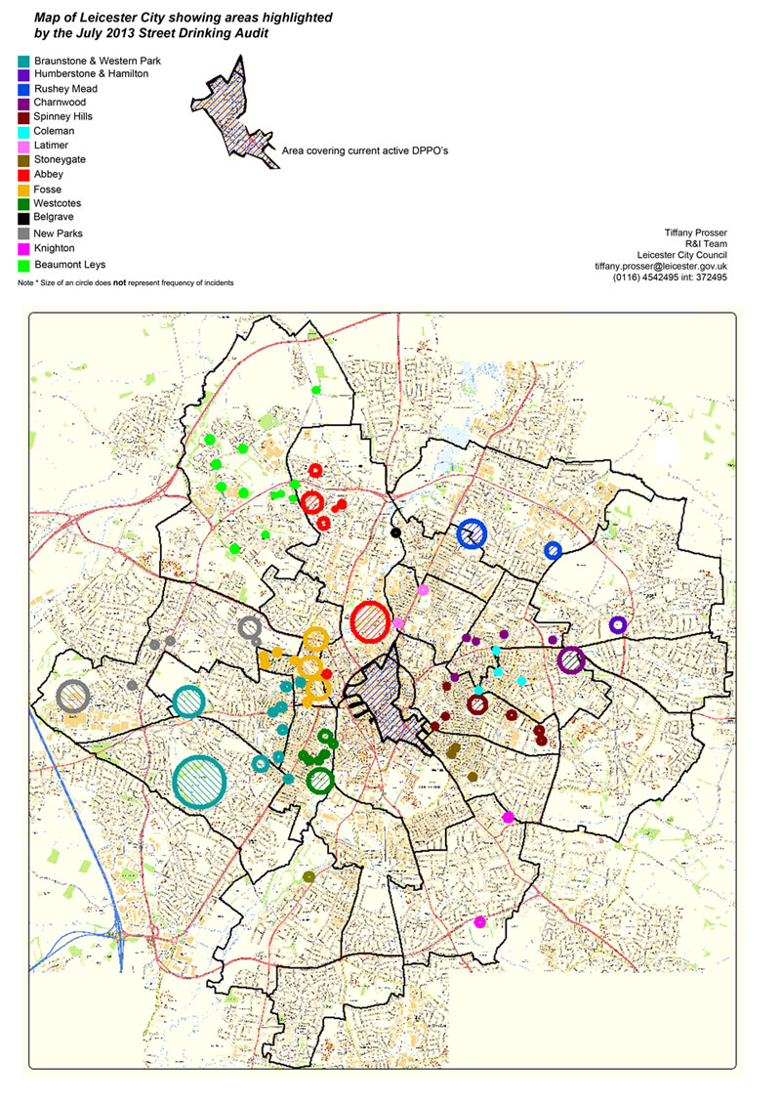

A recent audit report in Leicester (Street Drinking Audit, July 2013) showed that there are 106 street drinking hotspots across the city and approximately 15% of these occur in the city centre. Residents have raised concerns with us about irresponsible drinking of alcohol leading to anti-social or nuisance behaviour in public areas. This indicates that street drinking is significant enough for Leicester City Council to consider and implement a city-wide Designated Public Place Order (DPPO).

The DPPO gives police additional powers within a designated area to tackle street-drinking where there is associated anti-social behaviour (ASB).

A Police Officer or Police Community Support Officer can in a designated area:

  - Require a person not to consume alcohol
  - Require a person to surrender any alcohol in his/her possession
  - Dispose of the alcohol
  - Arrest an individual if they fail to comply with the Officer’s request and/ or fine the individual for up to £500.

The DPPO does not represent a ban on public drinking; it allows for greater control of drinking where it is of a problematic nature – e.g. large groups of drinkers intimidating residents/passers-by.

We need to consult with the public to establish exactly where street drinking is an issue, what problems it is causing and whether a city-wide order is supported by residents. If it is supported, we intend to implement the order by the end of September 2014.

QUESTIONNAIRE
If you would prefer to complete this questionnaire online or for more info including a larger version of the map and a Frequently Asked Questions (FAQ) guide – then please visit the Street Drinking consultation available at: http://consultations.leicester.gov.uk
- Do you think that street drinking is an issue in Leicester?
Yes □ No □ Undecided □

- Have you ever had a problem with street drinkers
Yes □ No □ Prefer not to say □

If you have not been personally affected by Street Drinking then please skip to question 3
- Was the problem with:
An individual □ A group □
- And how regularly was this a problem for you?
Everyday □ 3-4 times a week □ 2-3 times a month □ 2-3 times a year □
- Where did this occur?

(try to be as exact as possible - i.e. name of park, street, place, postcode etc.)
- What was the type of problem caused by the Street Drinkers?
Noise □ Verbal abuse □ Physical abuse □ Intimidation □ Littering □
Other _ _ _ _ _ _ _ _ __ _ _ _ _ __ _ _ _ _ __ _ _ _ _ __ _ _ _ _ _

- Do you agree that street drinking is a citywide problem as the map suggests?
Yes □ No □ Undecided □

- Do you support the use of a citywide street drinking order (DPPO)?
Yes □ No □ Undecided □
- If there anything else you would like to say about the subject then please use the space below:

- To help us analyse responses - please give us your postcode:: _ _ _ _ _ _ _ _ _ _ _

Thank you for your time, if you have any queries regarding this process then contact:

Louisa Barratt, Community Safety Assistant (Louisa.barratt@leicester.gov.uk)

Please return completed forms to: Louisa Barratt, Community Safety, Leicester City Council, Local Services and Environment, City Hall, 115 Charles Street, Leicester LE1 1FZ

