Beaumont Leys Library
Information Pack
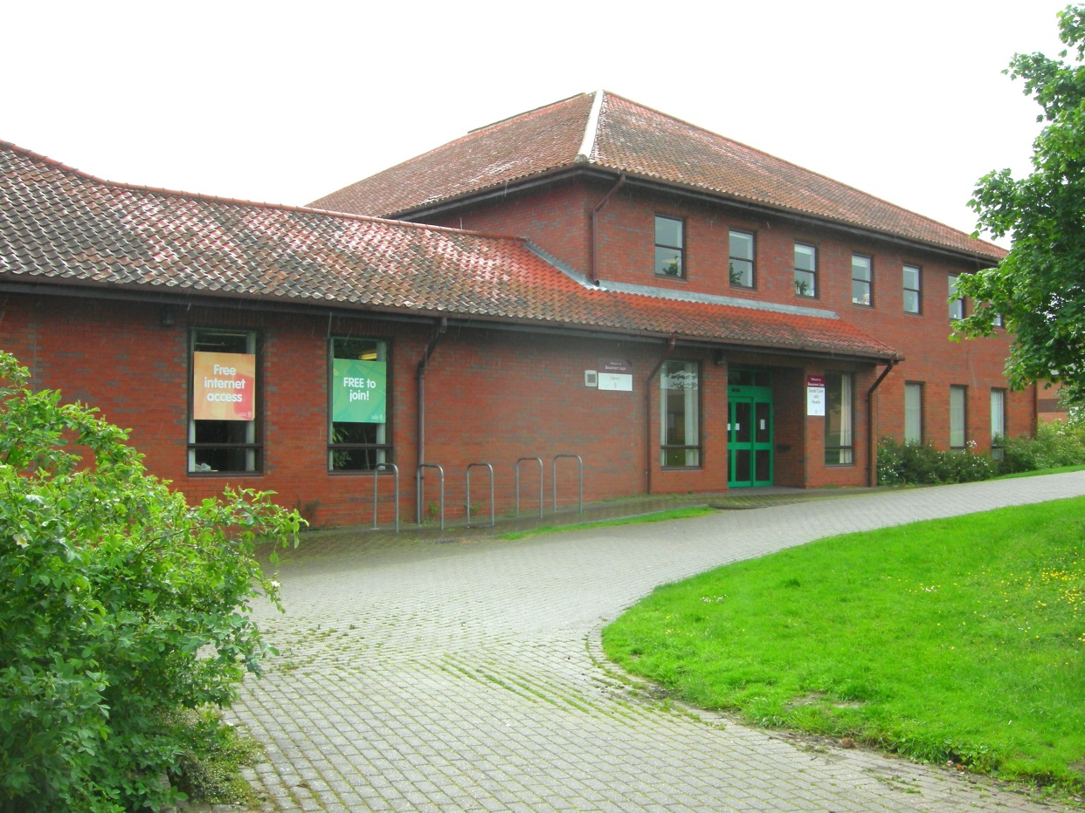
Beaumont Way, Leicester LE4 1DS
Tel: 0116 299 5460

Beaumont Leys Library Opening Times
 | Opening Times
Monday | 9.30am – 6.30pm
Tuesday | 9.30am – 6.30pm
Wednesday | 9.30am – 6.30pm
Thursday | 9.30am – 6.30pm
Friday | 9.30am – 5.00pm
Saturday | 10.00am – 4.00pm
Sunday | Closed

Floor Plan
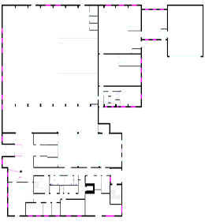

Additional Information
Annual costs and income

Account(T) | Amount
Building Works & Repairs/Maintenance/Alterations | £1,070
Building Services / Repairs & Maintenance Fixtures & Fittings | £1,181
Electricity Utilities | £13,254
Gas Utilities | £4,966
Non Domestic Rates - LCC | £36,738
Water Utilities | £753
Sewage Utilities | £2,399
Window Cleaning Contract | £24
Grounds Maintenance | £1,636
 | £62,020

