Braunstone Frith

Recreation Centre

Information Pack

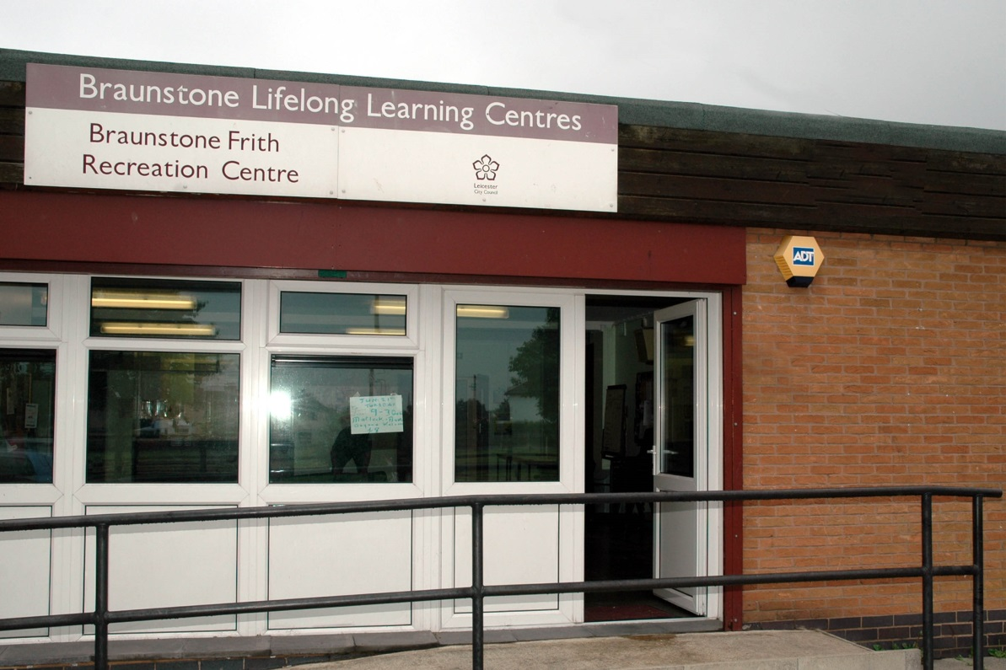

Sharman Crescent, Leicester, LE3 6NW

Tel: 0116 223 2350

**Braunstone Recreation Centre Opening Times**

|  |  |  |
| --- | --- | --- |
|  | **Available hours** | **Current Staffed hours** |
| **Monday** | 9am – 9pm | N/A |
| **Tuesday** | 9am – 9pm | N/A |
| **Wednesday** | 9am – 9pm | N/A |
| **Thursday** | 9am – 9pm | N/A |
| **Friday** | 9am – 9pm | N/A |
| **Saturday** | 9am – 9pm | **N/A** |
| **Sunday** | 9am – 9pm | **N/A** |

Floor Plans – Ground Floor

**KEY**

**Available Space**

**Dedicated Space**

Room 2

**Photos of Rooms/ Hire cost of Rooms**

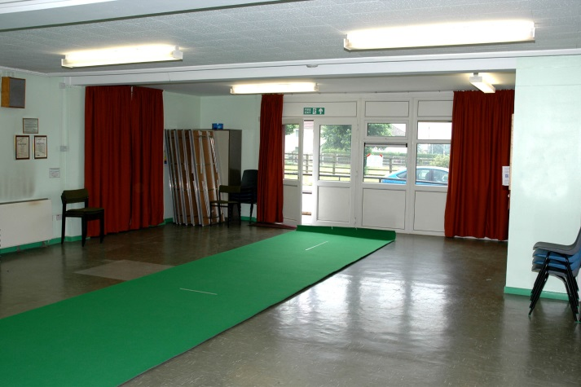

Main Hall – Small Centre FP Rm 2

FP = Floor Plan

|  |  |  |  |  |  |  |
| --- | --- | --- | --- | --- | --- | --- |
| **Band** | **Facility** |  | **Standard Rate** | **Community Group Rate (Regular Bookings) 65% Discount** | **Instructor Rate (Regular Bookings) 40% Discount** | **Commercial Rate** |
| 1 | Small Centre/Large Hall | **per hour** | 20.00 | 7.00 | 12.00 | 50.00 |
| 2 | Small Hall/Large Room | **per hour** | 16.00 | 5.50 | 9.50 | 40.00 |
| 3 | Medium Room | **per hour** | 12.00 | 4.00 | 7.00 | 30.00 |
| 4 | Small Room/Office | **per hour** | 8.00 | 3.00 | 5.00 | 20.00 |

**Hired Space Breakdown - (April 2014)**

|  |  |  |  |  |
| --- | --- | --- | --- | --- |
|  | **Number of Sessions** | **Weekly Average users** | **Hours of use** | **Weekly Income** |
| **Weekly Totals** | **4** | **115** | **39.5** | **£221.20** |

**Additional Information**

Costs and Income

|  |  |
| --- | --- |
| Room Hire Income 2013 / 2104 | £2314.55 |
| Minus running costs |  |
| Utility Cost – Electricity | £1526.86 |
| Utility Cost – Water | £228.75 |
| Utility Cost – Gas | N/A |
| Non Domestic Rates | £1247.40 |
| Total | - £688.46 |