New Parks Community Centre Information Pack

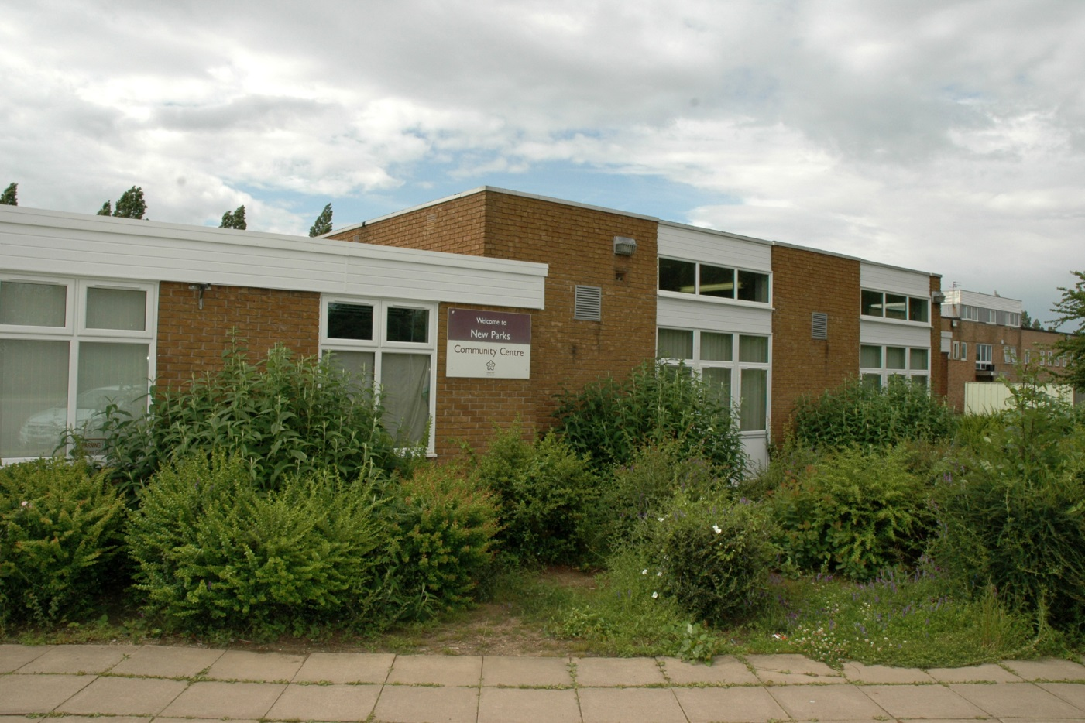

St Oswalds Road, Leicester, LE3 6RJ

Tel: 0116 222 1084

**New Parks Community Centre Opening Times**

|  |  |  |
| --- | --- | --- |
|  | **Available hours** | **Current Staffed hours** |
| **Monday** | 9am – 9pm | 12pm – 4pm (variable) |
| **Tuesday** | 9am – 9pm | 9am – 4pm (variable) |
| **Wednesday** | 9am – 9pm | 12pm – 4pm (variable) |
| **Thursday** | 9am – 9pm | 12pm – 4pm (variable) |
| **Friday** | 9am – 9pm | 12pm – 4pm (variable) |
| **Saturday** | 9am – 9pm | **-** |
| **Sunday** | 9am – 9pm | **-** |

Floor Plan

Room 17c

Room 20 - IT Suite

Adult Learning

Room 17c

Room 2b

Room 17b

Room 13a

Room 17a

**KEY**

**Available Space**

**Dedicated Space**

Pre-school

Early Years

**Photos of Rooms/ Hire Cost of Rooms**

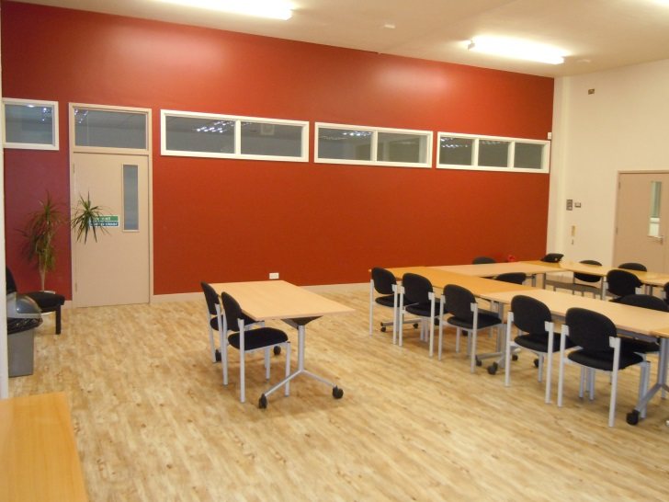

Main Hall – Small Hall FP Rm 17a

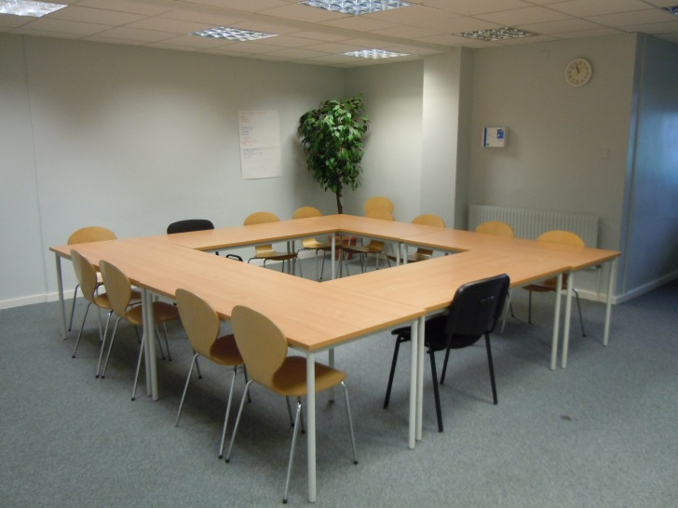

Activity Room – Medium Room FP Rm 13a

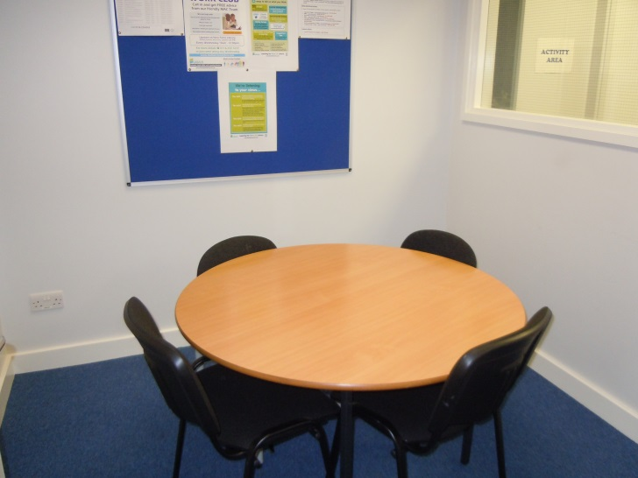

Interview Room 1 – Small Room FP Rm 2b

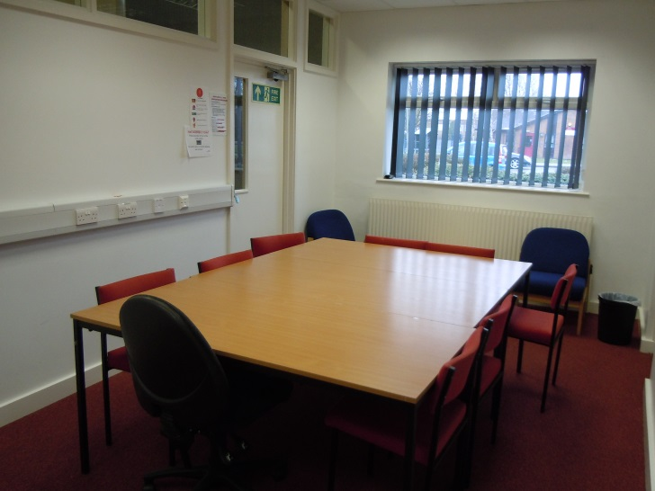

Meeting Room – Medium Room FP Rm 17c

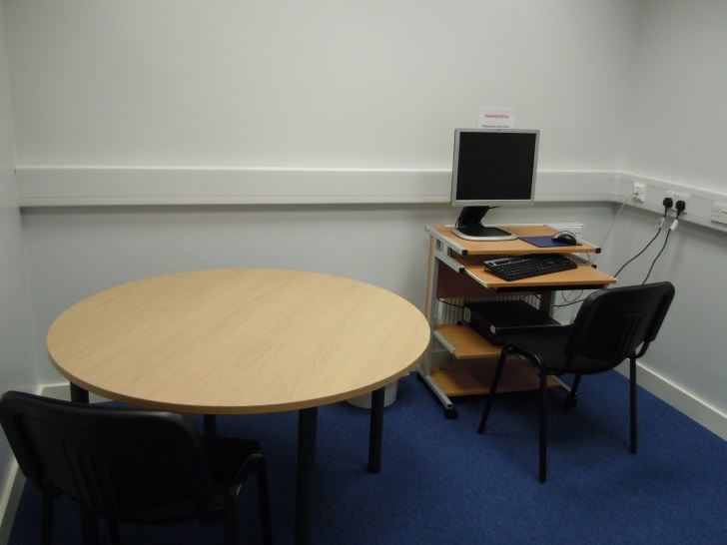

Interview Room 1 – Small Room FP Rm 17b

|  |  |  |  |  |  |  |
| --- | --- | --- | --- | --- | --- | --- |
| **Band** | **Facility** |  | **Standard Rate** | **Community Group Rate (Regular Bookings) 65% Discount** | **Instructor Rate (Regular Bookings) 40% Discount** | **Commercial Rate** |
| 1 | Small Centre/Large Hall | **per hour** | 20.00 | 7.00 | 12.00 | 50.00 |
| 2 | Small Hall/Large Room | **per hour** | 16.00 | 5.50 | 9.50 | 40.00 |
| 3 | Medium Room | **per hour** | 12.00 | 4.00 | 7.00 | 30.00 |
| 4 | Small Room/Office | **per hour** | 8.00 | 3.00 | 5.00 | 20.00 |

**Hired Space Breakdown - (April 2014)**

|  |  |  |  |  |
| --- | --- | --- | --- | --- |
|  | **Number of Sessions** | **Weekly Average users** | **Hours of use** | **Weekly Income** |
| **Weekly Totals** | 14 | 272 | 45 | £107.80 |

**Additional Information**

Costs and Income

|  |  |
| --- | --- |
| Room Hire Income 2013 / 2104 | £6159.75 |
| Minus running costs |  |
| Utility Cost – Electricity | £3413.01 |
| Utility Cost – Water | £1272.04 |
| Utility Cost – Gas | £9720.00 |
| Non Domestic Rates | £4065.00 |
| Total | -£12310.30 |