New Parks Library
Information Pack
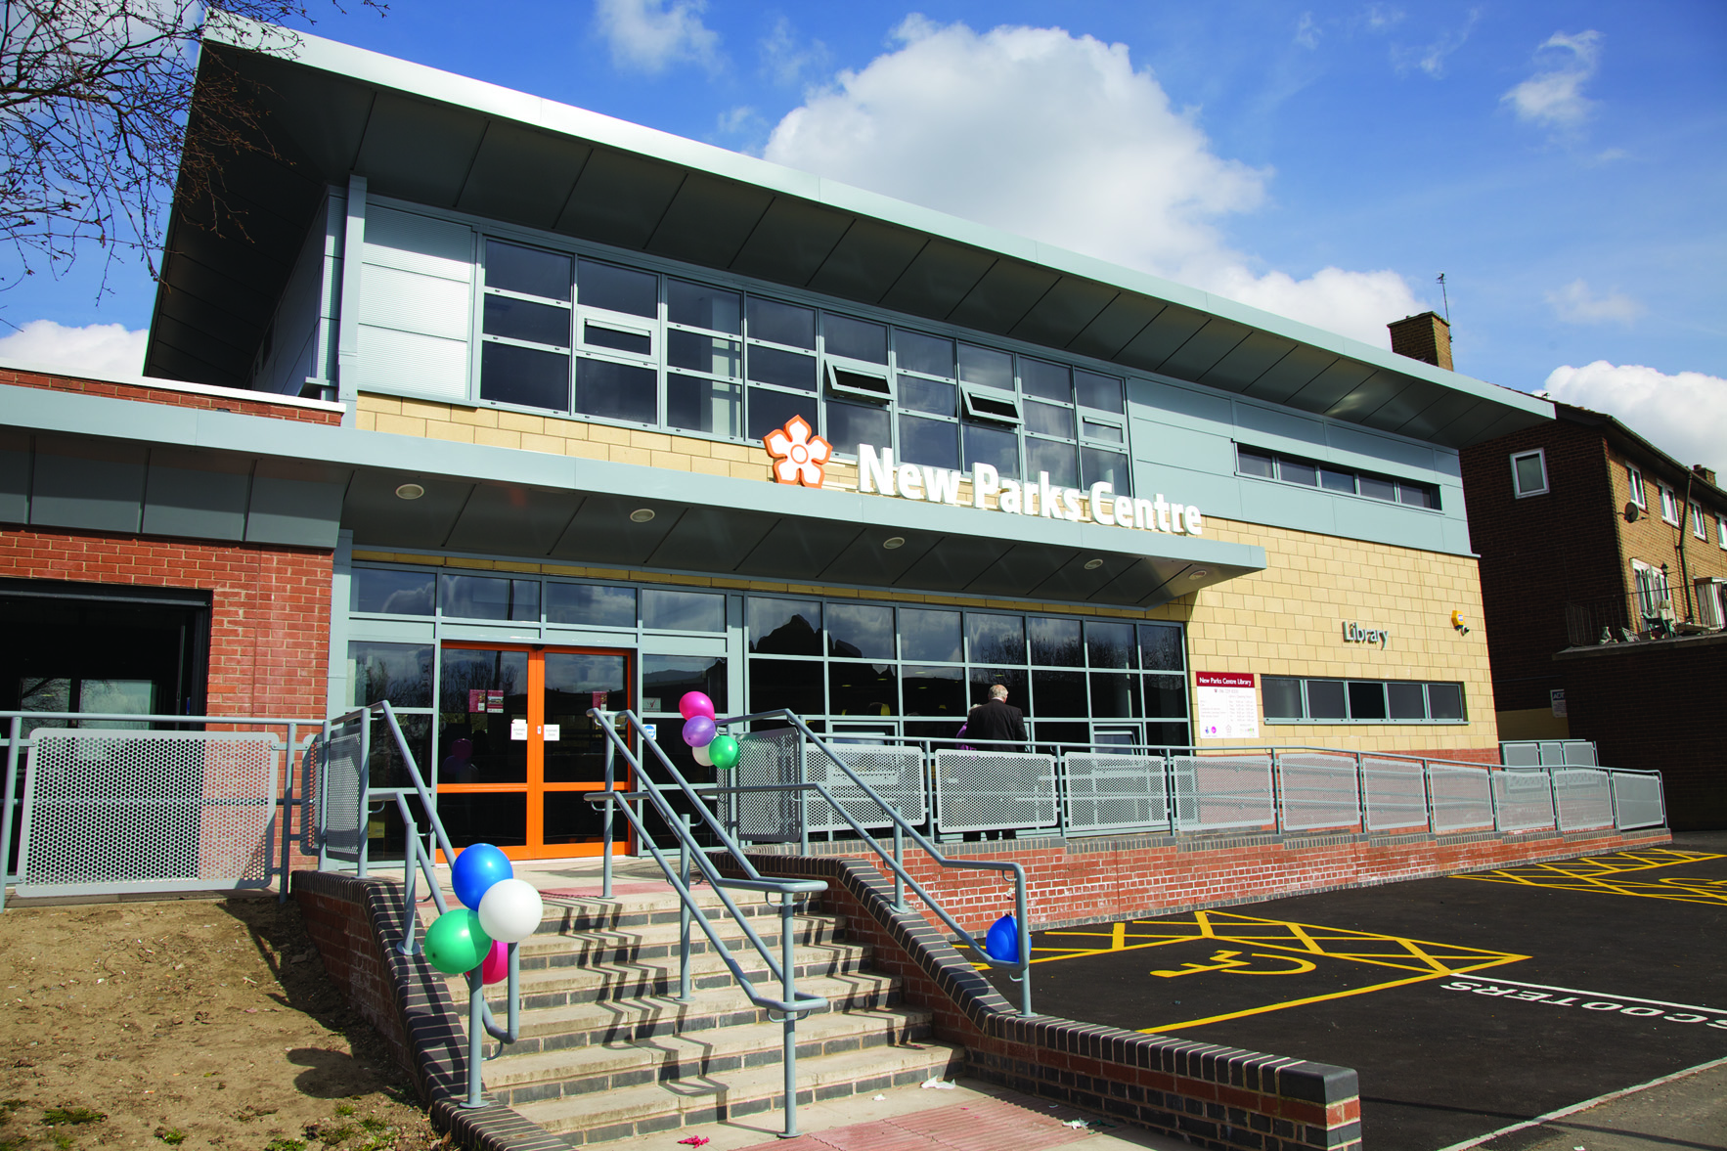
Aikman Avenue, Leicester LE3 9PW
Tel: 0116 229 8200

New Parks Library Opening Times
 | Opening Times
Monday | 10am - 2pm
Tuesday | 10am - 5pm
Wednesday | 10am - 7pm
Thursday | 10am - 5pm
Friday | 10am - 5pm
Saturday | 10am - 4pm
Sunday | Closed

Floor Plan
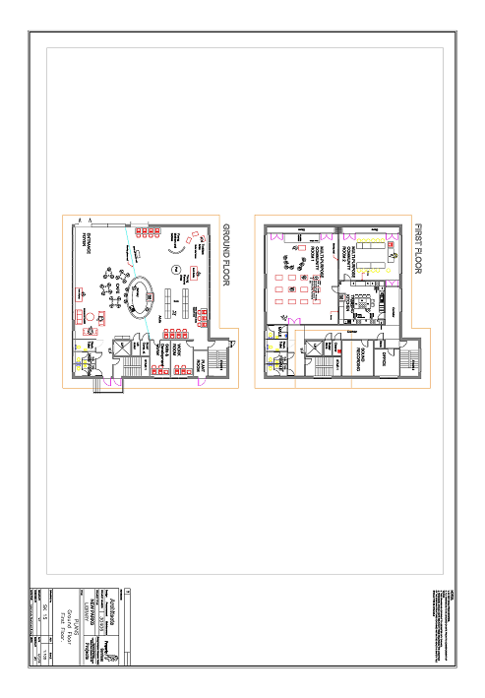
Additional Information
Annual costs and income

Account(T) | Amount
Building Works & Repairs/Maintenance/Alterations | £815
Building Services / Repairs & Maintenance Fixtures & Fittings | £935
Electricity Utilities | £11,495
Gas Utilities | £1,951
Non Domestic Rates - LCC | £26,376
Internal Contract Building Cleaning | £13,762
Window Cleaning Contract | £70
 | £55,404

