Council Tax Empty Homes Premium:
Consultation Findings

The consultation took place between 17 September and 14 October 2018, a period of four weeks. Consultations were available online and by paper form to download where required. Direct mailing was used to contact all charge payers currently liable for the Empty Homes Premium, and the consultation was promoted through awareness distributed via the Empty Homes Team, Housing Options, the Landlord Forum, the Social Welfare Advice Partnership and internally throughout the service.

In total, there were 83 responses to the consultation, which is relatively substantial for a premium affecting only 243 individuals.

Of the 83 responses received:
- 64 were a resident of Leicester;
- 6 were a landlord;
- 4 were a local business;
- 2 were a local charity;
- 15 were another individual or organisation.

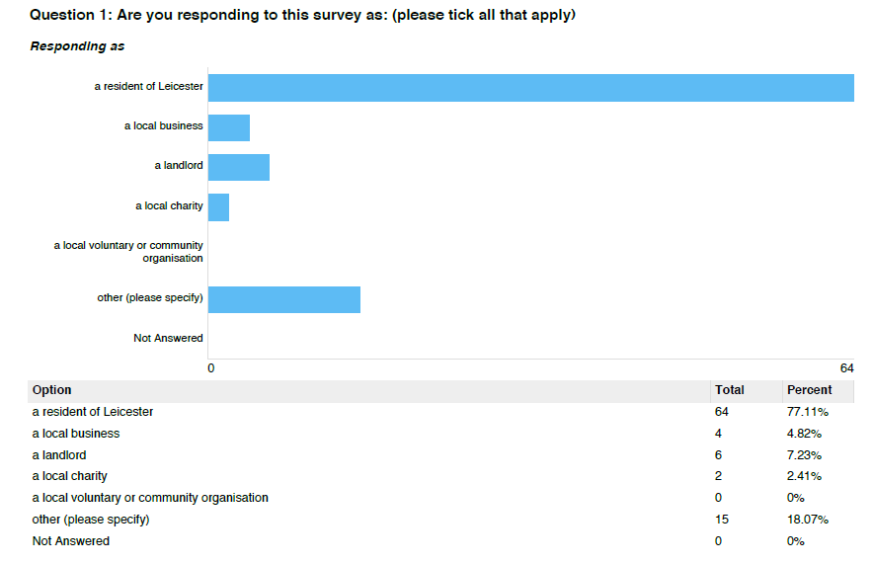

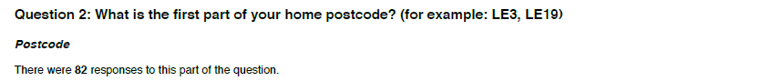

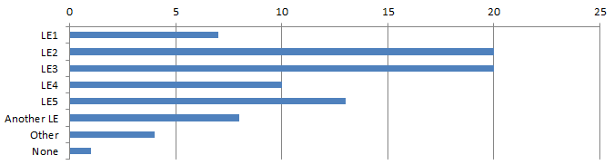
Option | Total | Per cent
LE1 | 7 | 8.43%
LE2 | 20 | 24.10%
LE3 | 20 | 24.10%
LE4 | 10 | 12.05%
LE5 | 13 | 15.66%
Another LE | 8 | 9.64%
Other | 4 | 4.82%
None | 1 | 1.20%
Total | 83

84% of respondents were based on the Leicester City area, 10% in the Leicestershire area and 5% outside of Leicestershire. However, all responses were considered valid as the owners of empty properties may well reside outside of Leicestershire and nevertheless be affected by any Empty Homes Premium increases.

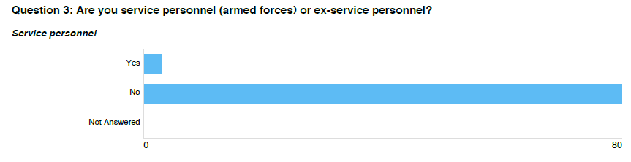
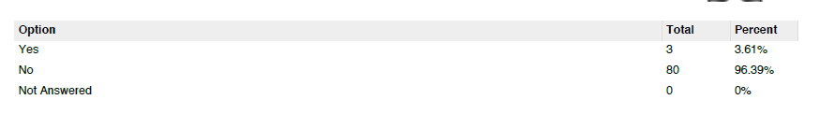

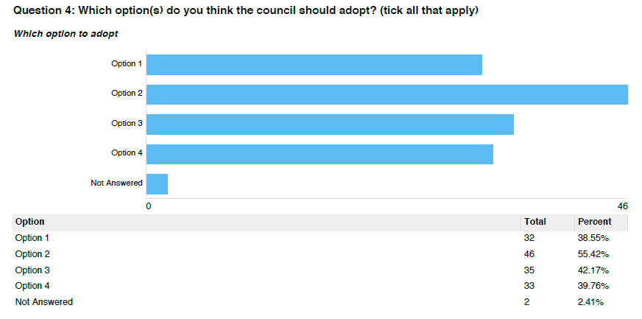

Of the 83 respondents:
- 32 (39%) supported no change to the scheme (Option 1).
- Most respondents (60%) supported introducing additional premiums – more than half (46, 55%) supported Option 2, 35 (42%) supported Option 3 and 33 (40%) supported Option 4.
- 2 respondents did not select any options.

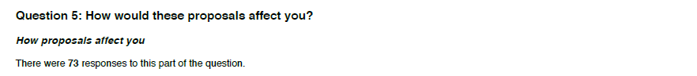

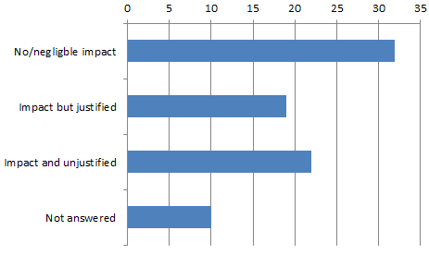

Response | Total | Per cent
No/negligible impact | 32 | 38.55%
Impact but justified | 19 | 22.89%
Impact and unjustified | 22 | 26.51%
Not answered | 10 | 12.05%
Total | 83

73 respondents provided a response to how the proposals would affect them.
- 32 (44% of respondents) felt the proposals would have no or negligible impact on them personally. There was however near-universal approval of the proposals in principle amongst this group, which were anticipated to have broader social benefits to the community including reduction in homelessness, reduction of derelict properties, improved Council finances and reduction of demand-driven rent increases.
- 19 (26%) acknowledged the proposals would have some financial impact on them, but nevertheless supported the policy objectives for the same reasons as the group outlined above.
- 22 (30%) felt the proposals would adversely affect them financially, and that the proposals were unjustified. Reasons included circumstances making properties difficult to renovate, let and sell, individual scenarios such as inheritance and ill health, and perceived unfairness impacting on a minority of charge payers.

Representative responses included:

“We are living with family while trying to do our house up but it is taking a lot longer than we anticipated and it now has been vacant for two years, so we are already paying the premium. However we would definitely have moved in by five years. I think people who have left their house empty for five years or more definitely are not intending to move in and should face double tax as they are just sitting on a spare property.”

“As a citizen of the city, concerned about homelessness and the lack of affordable housing for families in need, any policy that would encourage the owners of empty properties to bring them back into use should be encouraged. Empty properties are not desirable, not just because they potentially deprive people of a home, but they also sometimes attract anti-social behaviour, may become derelict and bring down the quality and perception of a whole area.”

“I think council tax is already high enough as it is. If you do this you are going to alienate the very people who could potentially help the homeless situation in the city. If you want to work with landlords do not financially penalise them it will just cause more problems than solving them. This will create a bigger divide between yourselves and the wider public that you are supposed to serve. I am already disgusted by the recent council tax rise, as it is nearly the equivalent of some of the publics take home pay for one month. With ever increasing costs I would think twice about becoming a landlord and property developer, which is something that I have given careful thought to.”

“The property is jointly owned by my mother, who has dementia, and step father who was incapable of managing the property any longer. I was awarded deputyship under the Court of Protection for my mothers’ finances in 2016 and took over management of this property this year after applying to the COP to be trustee. The property is currently for sale and we are doing our best to achieve a reasonable price, as directed by the COP.

The only thing that you have achieved by increasing council tax on this property and threatening to increase it further is to put even more pressure on me, someone who volunteered to help my mother, because of her dementia, and who already spends a great deal of time on this!”

33 respondents provided additional suggestions as to how the Council could save or raise more money. These included lobbying government for additional funds, reviewing Council pay structures, reducing other services and realising efficiencies in other areas such as street cleaning and Children’s centres, and increasing Council Tax liability more widely.
Notable responses included:

“The real question is when council properties were put on sale the funds should have been used to rebuild more properties but it was not. You want properties filled invite the landlord in for a discussion or write to them. I would look at getting feedback from property owner as to why they are empty in the first place. They may have idea that you have not thought of. Maybe the local council should look at how they can make savings or raise money internally instead of penalising landlords who in some cases have had to work very hard to obtain the properties that they do have.”

“First of all, this proposal would affect 350 properties: considering there are over 22000 houses in Leicester, the number of empty properties is incredibly low. In some touristic areas, the percentage is much, much higher. Therefore this proposal would not really benefit Council's revenue.
- A review of all the salaries of all members of staff earning over £45.000 per year would make more sense. Managers and directors of Local Authorities should be proud of working for the community and accept lower wages.
- Close more Children Centres: parents can meet in other places and/or in their own homes.
- Try to rent out all available spaces, including sharing offices with private sector.
- Increase taxation on COMMERCIAL empty properties: in proportion there are more of these than empty residential properties. Quite often Landlords prefer not to offer properties at lower rent and keep them empty. Bad for the economy and it looks awful.
- Increase Council Tax
Request more funding from central government. Cut expenses in other areas. Don't penalise residents, this will drive people out of Leicester City.”

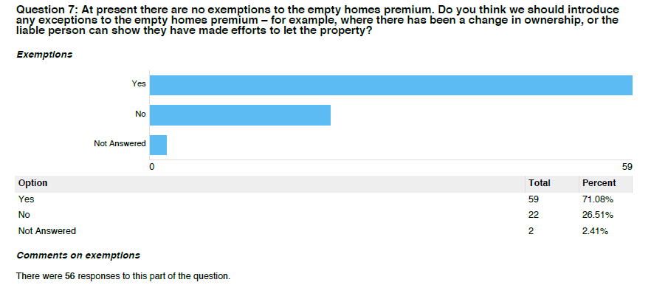

59 (71%) of respondents agreed that the Council should introduce exemptions to the Empty Homes Premium. 22 (27%) disagreed, and 2 provided no answer.

56 respondents provided suggestions as to exempt categories. These included:
- An exemption for charge payers making efforts to let properties, incorporating mitigating circumstances such as the condition of the property;
- A similar exemption for charge payers making efforts to sell properties, taking into account any restrictions on sale or recent change in ownership;
- Properties going through probate, or owner unable to manage their affairs.
- There were however concerns that the first two suggested exemptions could be exploited, and that any exemption should be time-limited.

Representative responses included:

“In the rare case that there are conditions on the sale of the property that the owner can demonstrate have prevented the sale or let, e.g. inherited property in a retirement community, otherwise, buyer beware. "Efforts to let" is not an excuse - if no-one is interested, try lowering the rent or improving the property.”

“I think an exemption would be good if a landlord could demonstrate reasonable efforts to let the property or if it has recently changed ownership. There'd need to be a time limit for the exemption though, for example, it would be reasonable to add an exemption if there had been a change of ownership in a 1-3 month period but after this time the new owner should really know what they plan to do with the property and should be making efforts to move in to it or let it out.”

“It would be good to have an exemption for empty properties when disability prompts a sudden unexpected need to change property and reduces ability to do the work required to empty the initial property while still fighting to complete other tasks in life like working, frequent hospital visits and time needed to recover from episodes of fatigue, numbness and other effects of the disability.”

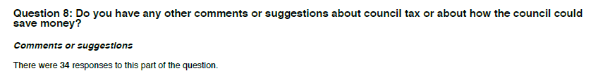
Responses were similar to the Option 1 question above, and included:

“Lower business rates/taxes on buildings that could have businesses that are currently are empty in the city centre. If having a business is made more affordable that will attract more people to set up businesses in the city centre and in turn would provide monetary reward over time for the council.”

“More enforcement cameras on bus lanes/ civil enforcement parking wardens.”

“Chase council tax fraud instead of turning a blind eye”

Outcome:
The consultation feedback was presented to full Council on 15 November 2018. The decision was made to adopt the proposed premiums of 100% for homes empty for more than two years in 2019/20, and to approve in principle adopting further premiums for homes left empty for five and ten years in 2020/21 and 2021/22. The Council decided to adopt the government recommended exemptions for occupants serving in the Armed Forces and self-contained annex properties.

